**Ideation Phase**

**Brainstorm & Idea Prioritization Template**

|  |  |
| --- | --- |
| Date | 15.11.2022 |
| Team ID | PNT2022TMID50737 |
| Project Name | Inventory Management system for retailers |
| Maximum Marks | 4 Marks |

**Brainstorm & Idea Prioritization Template:**

**Step-1: Team Gathering, Collaboration and Select the Problem Statement**

**Step-2: Brainstorm, Idea Listing**

**and Grouping**

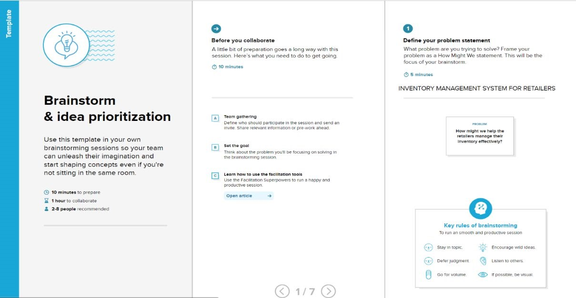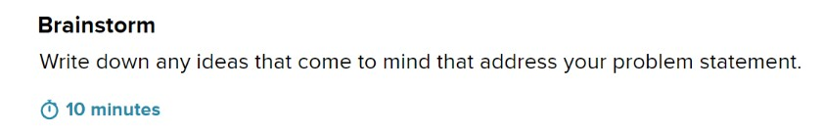

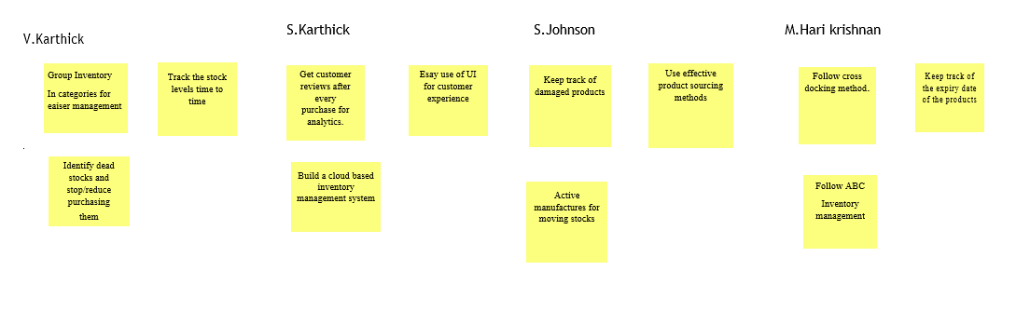

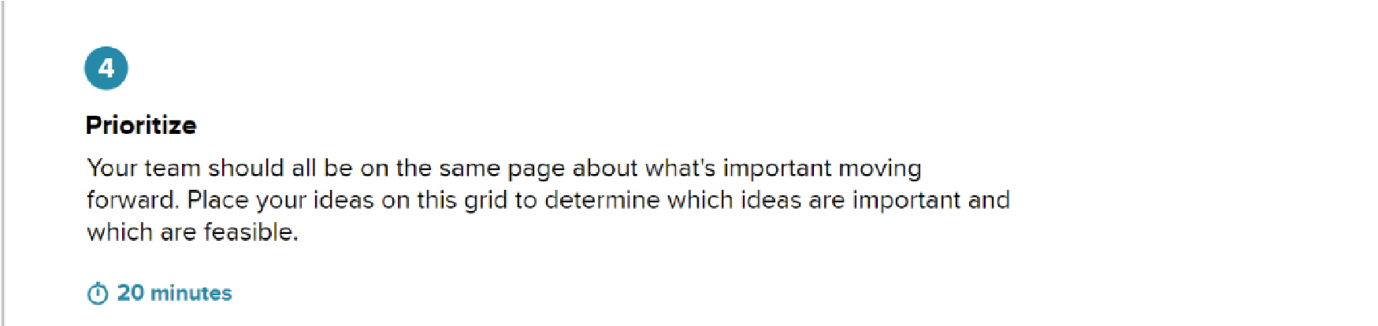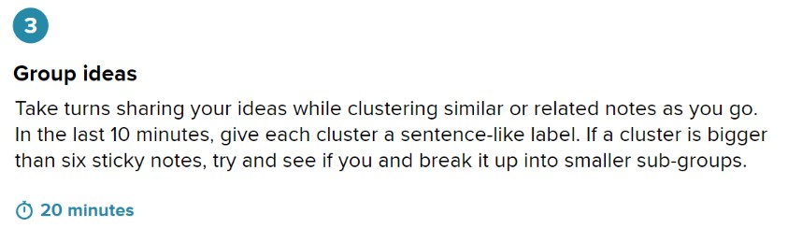

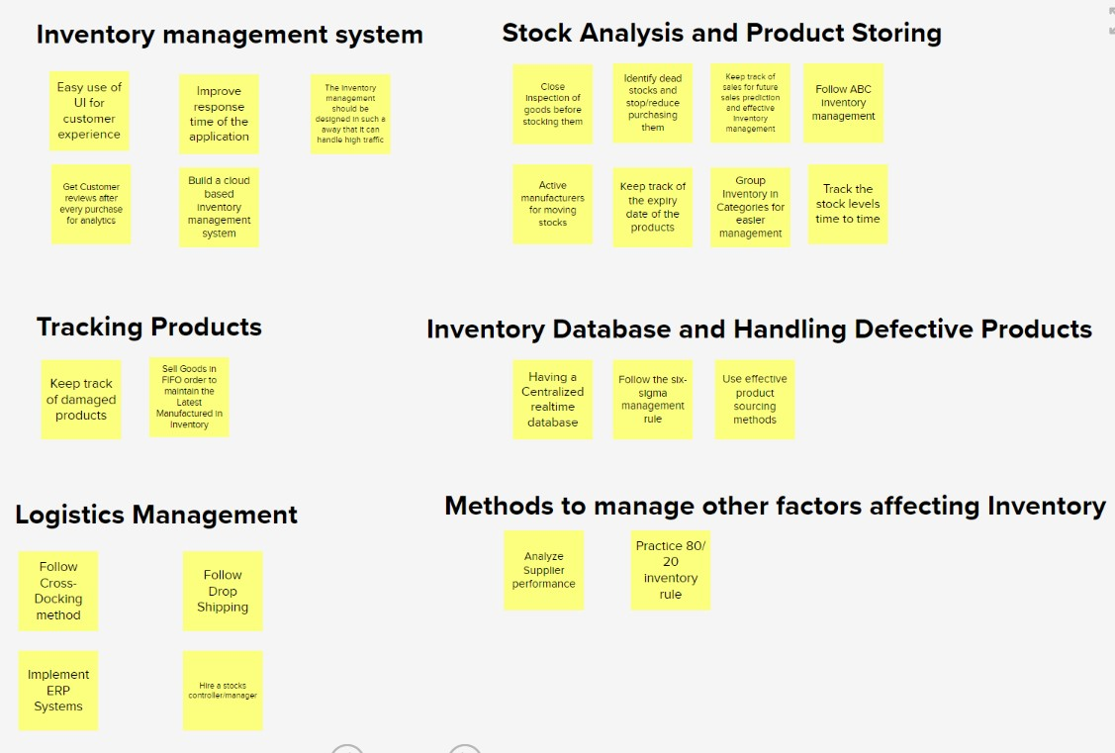

**Step-3: Idea Prioritization**

